**IT120: Systems Administration and Maintenance**

Laboratory Activity 3

Course Code: ______________

Name: ________________________________

Course/Year: __________________________

Direction: (40 points)

**Creating GITHUB account**

* Provide screenshots as evidence. Make use of the space provided.

**5 Points**

1. Create a free account in Github using the link <https://github.com>
   1. Log-on to your newly created account
   2. Screenshot the UI for your new account

|  |
| --- |
| Screenshot    I had an existing account. |

10 points

1. Create a Repository
   1. A repository is usually used to organize a single project. Repositories can contain folders and files, images, videos, spreadsheets, and data sets – anything related to your project needs. It is recommended that to include a *README*, or a file with information about your project.
   2. To create a new repository
      * In the upper right corner, next to your avatar or identicon, click + or NEW button.
      * The window of creation of new repository should be displayed
      * Name your repository as *hello-world*.
      * Write a short description
      * Select or CHECK the *Initialize this repository with README.*
   3. Click Create Repository

|  |
| --- |
| Screenshot: |

10 points

1. Create a Branch
   1. Branching is the way to work on different versions of a repository at one time.
   2. By default your repository has one branch name [main] which is considered be the definitive branch. We use brancher to experiment and make edits before committing them to [main].
   3. When you create a branch off the [main] branch, you’re making a copy, or snapshot, of [main] as it was at that point in time. If someone else made changes to the [main] branch while you were working on your branch, you could pull those updates.
      * The [main] branch
      * A new branch called [feature] takes before it’s merged into [main].
      * The journey that [feature] takes before it’s merged to [main] see figure

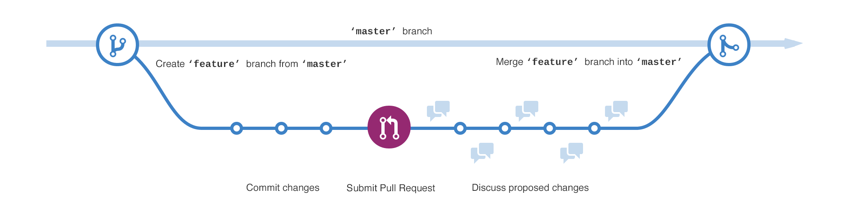

* 1. Create a new branch
     + Go to your new repository called *hello-world*.
     + Click the drop-down menu at the top of the file list that says ***branch:main***.
     + Type a branch name, *readme-edits,* into the new branchtext box
     + Select the blue Create branch box or hit “Enter” on your keyboard.

* Now you have two branches, [main] and [readme-edits].
  + What do you observe?

Answer: ______________________________________

|  |
| --- |
| Screenshot |

15 points

1. Make and Commit Changes
   1. Click the *README.md* file.
   2. Click the pencil icon in the upper right corner of the file view to edit.
   3. In the editor, write a bit about yourself.
   4. Write a commit message that describes your changes.
   5. Click the Commit changes button. See figure for sample

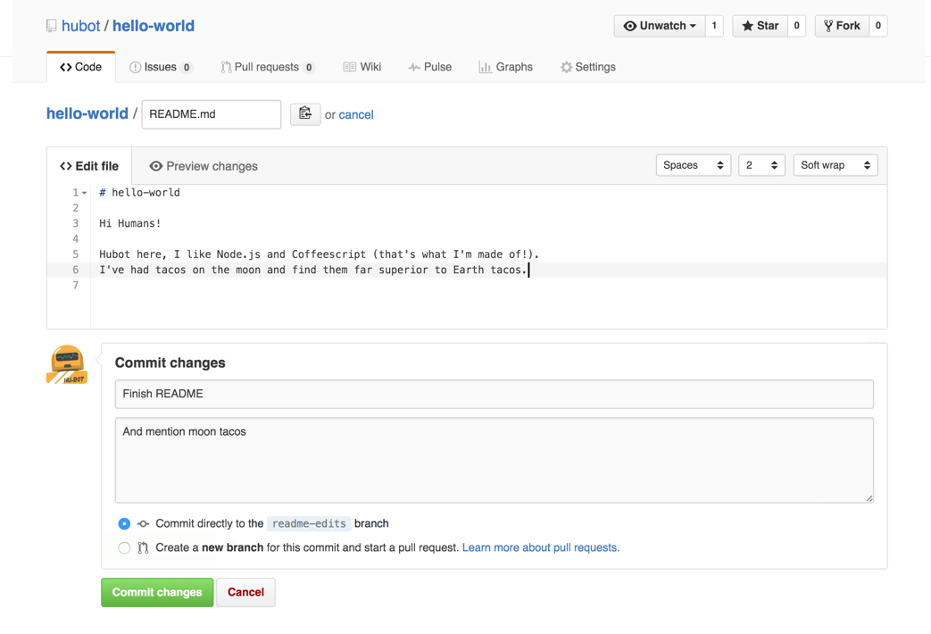

|  |
| --- |
| Screenshot |